Assignnment – 10

Q-1) Write a query that produce all pairs of salespeople who are living in the same city. Exc;ude combination of salespeople with themselves as well as duplicate rows with the order reversed.
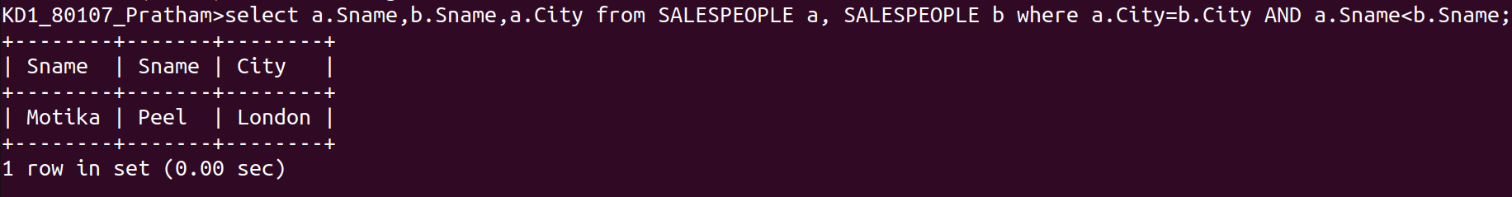

Q-2) Write a query that produce the names and cities of all customers with the same rating as Hoffman.

